*AFTER PUSHING ROUTINES, IF YOU WANT TO DO ANY CHANGES ON ROUTINES FOLLOW BELOW STEPS.*

EX: HAVE PUSHED ONE TEST FILE TO GERRIT, BELOW IS SCREEN SHOTS OF THE SAME IN GERRIT

* Screen shot-1 below is the commit

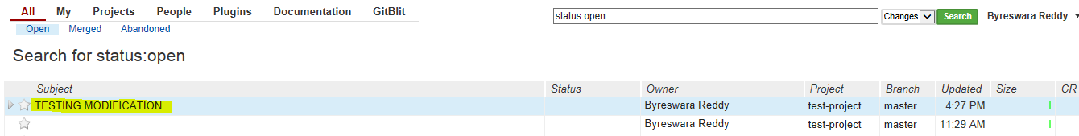

* Screen shot-2 below is the test file and you can observe pathset 1/1

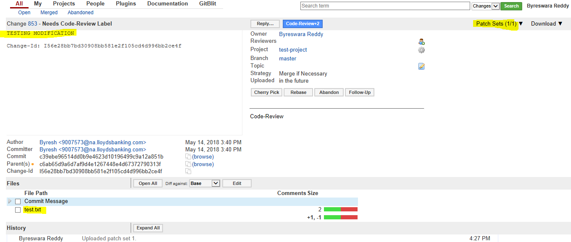

* Screen shot-3 below is the changes done in test file

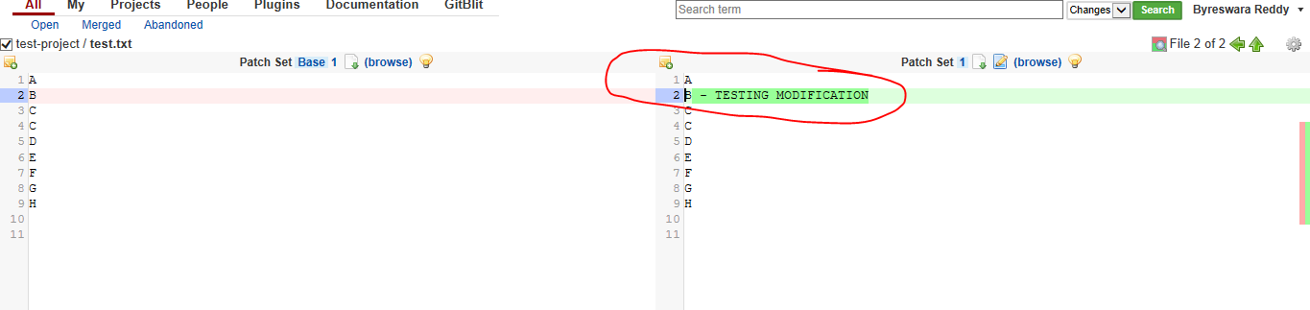

* Screen shot-4 Below screen shot is , have changes on the same test file and we should click icon amend then it will automatically pop up previous commit message and click commit and push

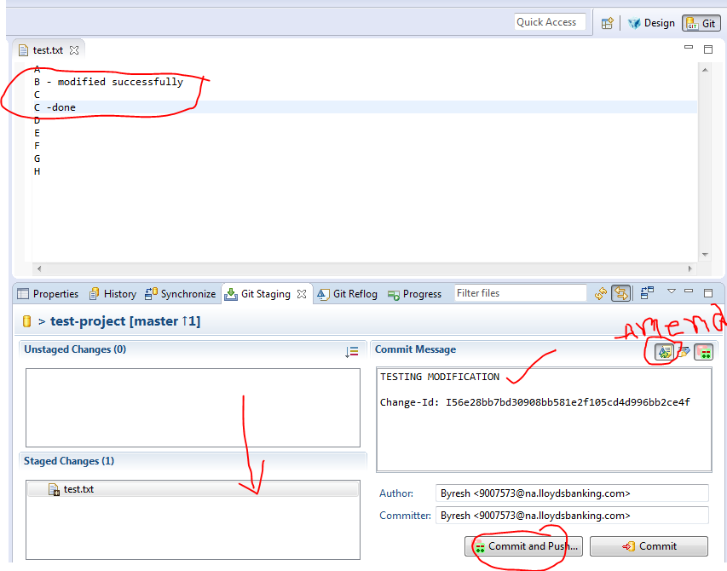

* Screen shot-5 below is the same test file after changes you can observe pathset 2/2

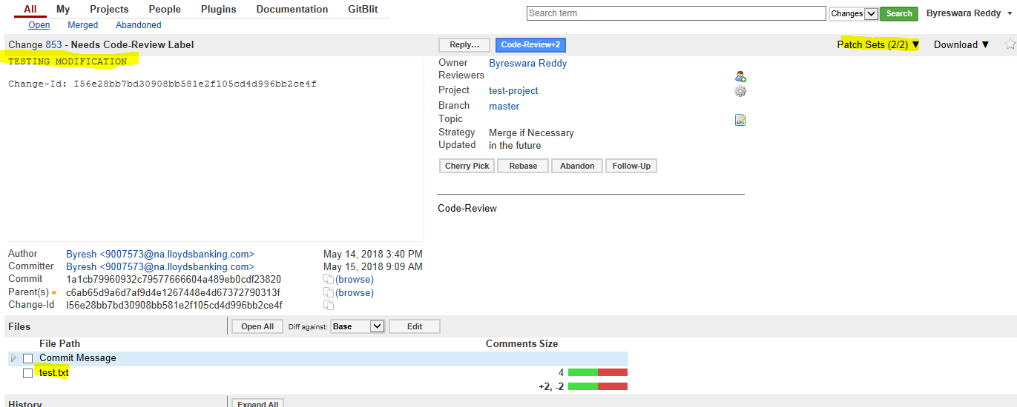

* Screen shot-6 now you can see 2nd time chnges withourt abandon the testfile.

